
Invitation for Thursday, 10th of September NZISF seminar (on ZOOM)

or use 
Seminar topic:
Digital Safety and Security: Do we need a paradigm shift?
Vulnerability discovery, disclosure, and exploitation are accelerating at an exponential rate. The associated institutional costs are becoming so overwhelming that headline costs in the $Millions are now trivial... nonetheless, the real on-the-ground human costs are immense and, at times, could be life-changing.
Gabriel is proposing a paradigm shift that may begin to change technology-driven/related service delivery architectures and promote safe and secure technology ecosystems that include service-user communities.
Presenter:
Gabriel Akindeju
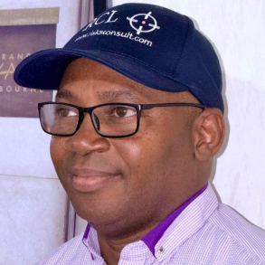

Gabriel Akindeju (CIPT, CGEIT, CRISC. CISM. CISSP. CISA. SCF. M(ISC)2. MISACA.) is a Technology GRC, Security, and Privacy thought leader with extensive senior leadership experience across multiple industries and countries. His primary professional goals are helping organisations:
- leverage effective management of technology-related risks, including but not limited to security and privacy, for the creation of stakeholder values by optimising risk-reward dynamics;
- prevent value erosion by deploying an effective risk and operations management framework and processes;
- safely and securely recover when issues and incidents arise.

Details for registration

or use 
- Registration fee: $10.00.
- If you would like to invite someone to attend this seminar, then pass this invitation to that person. Alternatively, you may buy a ticket for that person. This means place the person's name, email and phone number on the ticket for that person. This way login info will be sent to the recipient of that ticket.
- Registrations will be accepted until noon on Wednesday, the 9th of September. Please note that the later registrations may not be processed.
- ZOOM login will be circulated to attenders on Wednesday afternoon on 9th of September.

Partner


Sponsors



To place your name on the NZISF mailing list, click here
To remove your name from the NZISF mailing list, click here
Lech Janczewski
MEng, MASc, DEng
Honorary Professor
NZISF Chair
M +64 27 404 8884 | E lech@auckland.ac.nz


